FOOD ORDERING SYSTEM
ABSTRACT

A Food ordering system is a used inside the hotel or restaurant, because this is not an online application, which application can use only inside the restaurant. Admin first should allocate the menu item list in the menu item list adding menu. Once the admin added the food items in the list will be displayed in the all the customer places. The customer can place the order in where he sitting in the place, no need to request food by the supplier. Once the order has been placing the kitchen server has receive some notification and he can prepare it. There are some modules are using this application which are may take differ from different scenario.
This is very modern way to accessing the application, which is very user friendly and common application, here Front as JAVA and back end as SQL.

SYSTEM SPECIFICATION
HARDWARE SPECFICATION:
- Processor : P 4 700 GHz.
- RAM : 4 GB RAM
- Hard Disk Drive : 180 GB

SOFTWARE SPECIFICATION:

  - Operating System : Windows 7/8/10
  - Front End : JAVA
  - Back End : SQL

EXISTING SYSTEM
Before the canteen automation system, a customer needs to first ask menu list from waiter then choose menu then again call waiter then order the food. Which could be takes more time to ordering a single food. Sometimes if the waiter has busy with some customer it make some irritate feeling to the canteen. So, its very hard to maintain the canteen system.
DISADVANTAGES:
- Customer don’t know about the food details
- Waste of time to waiting for a waiter.
- Easy to ordering a food

PROPOSED SYSTEM
This system helps to ordering a food manually by the customer. Customer can choose their favorite food without asking the waiter. This might be reducing time of ordering a food. Every tables have one system, with this system helps to ordering a food, then the order will be visible to the cooking team they will saw and preparing and delivering a food.
ADVANTAGES:
- Attractive user interface
- Every user can be easily to use this software.
- Taking less time to ordering a food
Modules
- Menu list entry
- menu list details
- Food order
- Food order history
- Billing details

Menu Items Entry
Menu items was added by admin, these menu items will change daily base. Customer can easily find what are the dishes are available now, then they will order his favorite food.
Menu List Details
This module will show all the details for the menu items, this is an main module user able to see this menu item list and make an order from the table,
Food order
Once customer was given an order the order was send to the waiter, the waiter will be verifying and delivered that order.
Food order history
Waiter can check the food order details, every table has unique screen to view the order history, once the order has done, they will provide. These screens will show only for waiters.
Billing Module
This module only shown to the manager and customers, they can check the table wise billing details as well. These processes can be monitored by the manager and collect the bill to cashier.

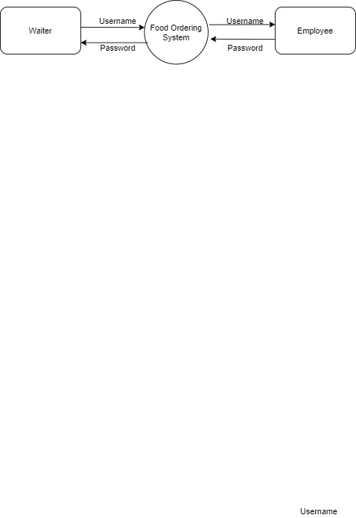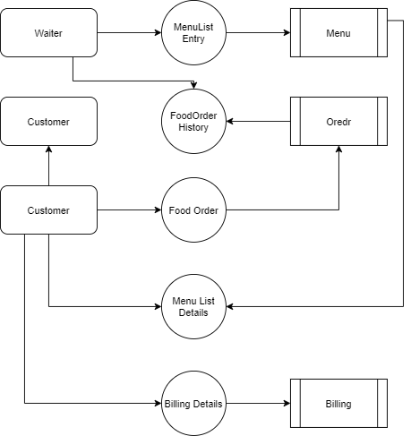

TABLE NAME: WAITER
FIELD | DATA TYPE | SIZE | CONSTRAINT
Waiter id | Int | 10 | Primary key
Waiter name | Varchar | 20 | Not null
Username | Varchar | 20 | Not null
password | Varchar | 20 | Not null

TABLE NAME: MENU’S
FIELD | DATA TYPE | SIZE | CONSTRAINT
Menu id | Int | 10 | Primary key
Food name | Varchar | 20 | Not null
Cost | Int | 10 | Not null
Food image | Int | 10 | Not null

TABLE NAME: ORDER
FIELD | DATA TYPE | SIZE | CONSTRAINT
Order id | Int | 10 | Primary key
Table id | Int | 10 | Foreign key
Menu id | Int | 10 | Foreign key
Quantity | Int | 5 | Not null
Order status | Varchar | 10 | Not null

TABLE NAME: BILLING
FIELD | DATA TYPE | SIZE | CONSTRAINT
Bill id | Int | 10 | Primary key
Order id | Int | 10 | Foreign key
Customer name | Varchar | 20 | Not null
Total amount | Int | 10 | Not null

